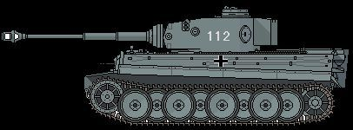
Figure 1Panzer leher
116th Pz
+2

